**Analysis project 2**

**Step 1:**

**3a. Provide a scatterplot between Intimidation before and Intimidation after.**

Answer:

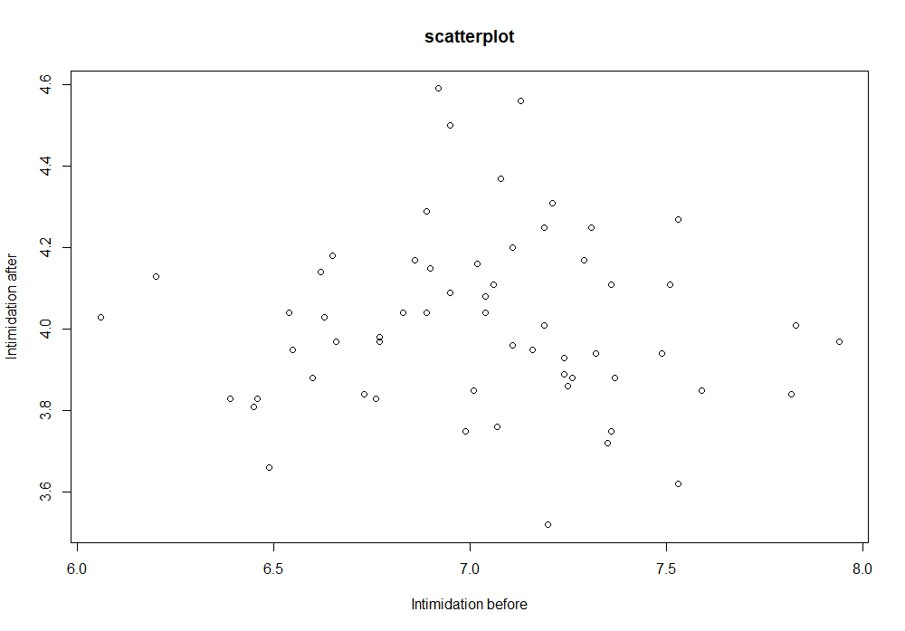

**3b. What Score on the Final is at the 70th percentile?**

Answer: 83.188

**3c. Provide a histogram for the Final variable.**

Answer: 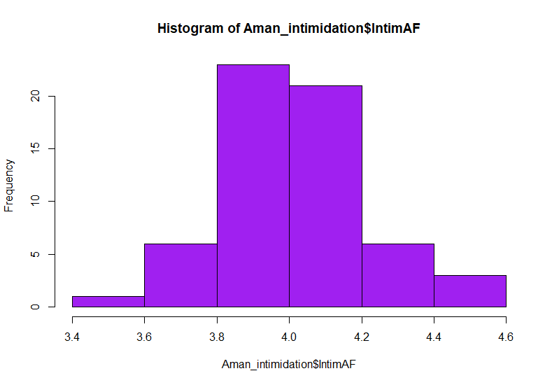

**3d. Using the base R commands, determine what the frequencies, relative frequencies, and**

**percentages are for each category of the Major variable.**

Answer:

1. Frequencies:

|  |  |  |
| --- | --- | --- |
| Early Childhood | Elementary Ed | Secondary Ed |
| 18 | 24 | 18 |

1. Relative frequencies:

|  |  |  |
| --- | --- | --- |
| Early Childhood | Elementary Ed | Secondary Ed |
| 0.3 | 0.4 | 0.3 |

1. Percentage:

|  |  |  |
| --- | --- | --- |
| Early Childhood | Elementary Ed | Secondary Ed |
| 30 | 40 | 30 |

**Combined Result:**

|  |  |  |  |
| --- | --- | --- | --- |
|  | Frequency | Relative Frequency | Percent |
| Early Childhood | 18 | 0.3 | 30 |
| Elementary Ed | 24 | 0.4 | 40 |
| Secondary Ed | 18 | 0.3 | 30 |

**3e. Provide a Bar chart for the Major variable.**

Answer:

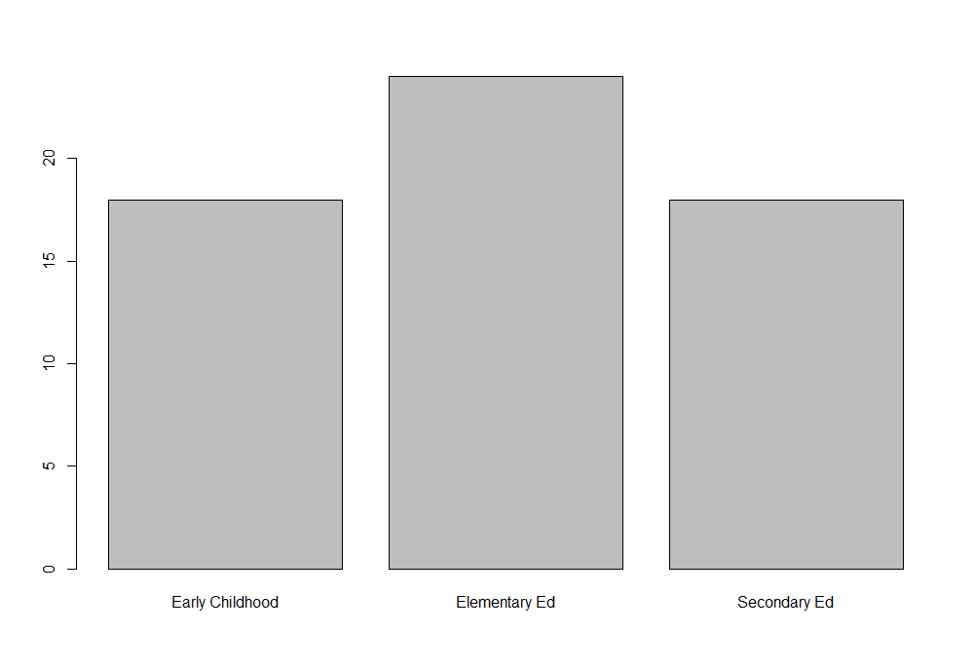

**3f. Using the tableone package, determine what the frequencies and percentages are for each**

**category of the Biosex and Year variables**

Answer:

|  |  |  |  |
| --- | --- | --- | --- |
| **Variable** | | **Frequency** | **Percent** |
| Overall (n) = 60 | | | |
| Biosex | Female | 36 | 60.0% |
| Male | 24 | 40.0% |
| Year | Freshman | 4 | 6.7% |
| Sophomore | 12 | 20.0% |
| Junior | 28 | 46.7% |
| Senior | 10 | 16.7% |
| Graduate | 6 | 10.0% |

# Here, it is shown that, ‘tableone’ is not providing the decimal digit more than one for the ‘percentage’. Therefore, to get accurate percentage for 'Year', base package is used to analyze Frequencies and Percentages for each nominal and ordinal values in APA write up.

**Step 2:**

**APA Write Up**

**A total of 60 participants took part in the study. Table 1 presents the Frequencies and percentages for categorical variables. In the analysis for Year category, 4 (6.667%) participants are from Freshman year, 12 (20.0%) from Sophomore, 28 (46.667%) from Junior, 10 (16.667%) members are from Senior year and 6 (10.0%) are graduates.**

*Table 1: Frequencies and Percentages for each nominal and ordinal values*

|  |  |  |  |
| --- | --- | --- | --- |
| **Variable** | | **Frequency** | **Percent** |
| Overall (n) = 60 | | | |
| Biosex | Female | 36 | 60.0% |
| Male | 24 | 40.0% |
| Major | Early Childhood | 18 | 30.0% |
|  | Elementary Ed | 24 | 40.0% |
|  | Secondary Ed | 18 | 30.0% |
| Year | Freshman | 4 | 6.667% |
| Sophomore | 12 | 20.0% |
| Junior | 28 | 46.667% |
| Senior | 10 | 16.667% |
| Graduate | 6 | 10.0% |